Scottish Mentoring Network’s Quality Award for Mentoring Services
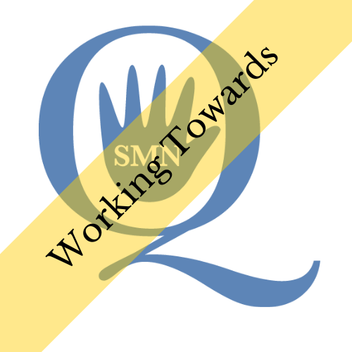

The Scottish Mentoring Network Quality Award is a user friendly, online process to provide recognition, benchmarking and an independent health check for mentoring services.

History
Previously Scottish Mentoring Network offered the opportunity to its members to apply for a Quality standard called ‘Approved Provider Standard’. The award was managed by the Mentoring and Befriending foundation based in England and Wales. Subsequently, the application process for the award was significantly altered and as a result it would have been very expensive for Scottish services to achieve ‘Approved Provider Standard’.
Scottish Mentoring Network recognised the value in our member services being able to work towards and achieve a Quality Standard and therefore decided that we should develop a standard that specifically relates to mentoring services operating in Scotland.
The SMN Quality Award is the result of this process.
We are now able to offer the Quality Award to mentoring services throughout the rest of the UK, as the Mentoring and Befriending Foundation no longer operates.
Purpose of the Quality Award
A mentoring service’s decision to apply for quality standard demonstrates a commitment to delivering a service which focuses on the expectations and requirements of all its stakeholders.
The achievement of the quality award is confirmation that the service is applying recognised good practice to all aspects of its work.
Consequently every stakeholder can have the confidence that their involvement in the service will be managed professionally and to a level validated by Scottish Mentoring Network.
What the Quality Award means to key stakeholders:
Funders
These providers will be able to identify which services have the systems and expertise in place to manage their financial and staff resources effectively and are designed to deliver services which will meet contract requirements. When comparing service bids, funders will have a recognised benchmark to assess respective service capabilities.
Referral agencies
When signposting their clients to partner services, these agencies can expect the mentoring service to have processes in place which ensure that their clients will be supported by trained and supervised mentors and that these relationships will be effectively managed throughout their duration.

Clients/Service users/Mentees
The client can expect that their specific needs will be fully assessed by the service to ensure that the service is appropriate for them, that they will be matched with a suitable mentor and that their progress and support will be the key priority of the service.
Mentors and volunteer agencies
The mentor can expect to be involved in a service which will manage their recruitment, selection and training professionally and which will be committed to enhancing the mentor’s experience throughout their relationships.
Service staff
Staff members can expect to operate within a management system which maintains a focus on their individual performance and on developing their skills and knowledge to ensure that the service continues to meet the expectations of all its stakeholders.
Core Quality Practice elements that will be measured
The standard is designed around six core quality practice elements. Each element addresses what level of performance a mentoring service is expected to demonstrate to achieve the Quality Award. Each core practice element has a general definition to describe what an effective mentoring service is expected to demonstrate. The expectations for each core practice area can be summarised as follows:
- Matching purpose with performance
An effective mentoring service is clear about what it is designed to achieve, can demonstrate its impact in ways which are relevant to it stakeholders and has a commitment to continuous improvement.

- Managing resources and accountability
All aspects of managing the service’s resources comply with recognised good practice and the service is accountable to its stakeholders in a way which is transparent and understandable.

- Putting the client first
The design and delivery of the mentoring service is dictated by the specific needs of its client group so that their best interests are at the heart of its service.
- Providing committed mentors
The service is geared to providing mentors who have the commitment and attributes required to work productively with the client group.

- Employing skilled staff
The service ensures that skills and knowledge of its staff are directly linked to effective service delivery and that staff performance is geared to meeting stakeholder requirements.
- Active safeguarding
The service makes the safeguarding of its participants a central priority and has the policies and procedures in place to demonstrate this commitment.
Practical Details
- Organisations must be members of SMN to apply for the Quality Award. Mentoring Projects operating in Scotland can apply to be a member (General Members). Associate Membership is available to individuals who are sole traders involved in the provision of training, to organisations with mentoring projects not operating in Scotland and to other organisations with an interest in mentoring which supports the aims and activities of the company. General Membership is open to any local, regional or national organisation involved in delivering mentoring in Scotland which supports the aims and activities of Scottish Mentoring Network. Associate Membership is open to individuals who are sole traders involved in the provision of training, to organisations with an interest in mentoring which supports the aims and activities of the company and to mentoring projects who are not operating in Scotland.
- Mentoring Services must have completed one full cycle of matches to be able to generate the evidence required for Quality Award assessment to take place.
- Once registered for undertaking the Quality Award, applicants will have one year to complete their application. During this time they will be awarded ‘Working Towards’ status.
- The Quality Award accreditation once gained applies to the service for a 3 year period unless there are any significant changes in its operation.
- The completion of the Quality Award take place using an online system.
- Ongoing support is available to projects throughout the duration of the application process from SMN staff.

Getting Started
- If you are interested in signing up for the Quality Award, contact Amanda Skinner-Welsh, Training and Project Support Lead, via phone or email:
  - 07399296066
  - Amanda@scottishmentoringnetwork.co.uk
- Once you have agreed to go ahead, we will send an invoice for the initial payment and register your Working Towards Status (£300 – members rate, £450 – associate members rate).
- Once payment has been received, you will be given access to the online system where you can upload evidence relating to each Quality Practice Indicator and will be given access to the ‘Working Towards’ logo to share with stakeholders.
- You will have one year, supported, to complete the award before submitting for assessment. If you need longer than a year to work on your award you can reapply for
the working towards status (£300 – members rate, £450 – associate members rate), and continue to receive support until you are ready for assessment.
- When you are ready for assessment you will be invoiced for the assessment fee (£300 – members rate, £450 – associate members rate)
- After submitting for assessment, you will be informed in writing if you have achieved the award and will be sent a copy of your certificate and the Quality Award logos to use on your mentoring service’s marketing materials.
- Your accreditation is valid for 3 years provided you don’t fundamentally change the way you operate your service. After three years, you will be contacted about completing your reaccreditation.

Feedback for the Quality Award Service

“…it is sometimes difficult to realise we don't have everything in place, but also recognising the confidence and satisfaction to get everything in to place and then be recognised for it.”

“The Quality Award team were very friendly and helpful”.

